Assignment 1

(100 pts total)
Analyze the provided survey (Drinking Survey) and survey data (drink217.sav) and answer the following questions about the survey and the sample.
- What percent of the respondents are freshmen and sophomores? Is the sample representative of the student population? (10 pts)
Solution
SPSS output
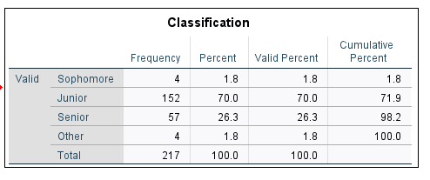
-From the SPSS output, we have 0% Freshmen and 1.8% sophomore.
- $\left(0+1.8\right)\%=1.8\%$
-The sample does NOT SEEM to be a representative of the student population, since it does not include any percentage of Freshmen in the survey.

- What percent of the respondents are under age 21? (10 pts)
solution
SPSS output
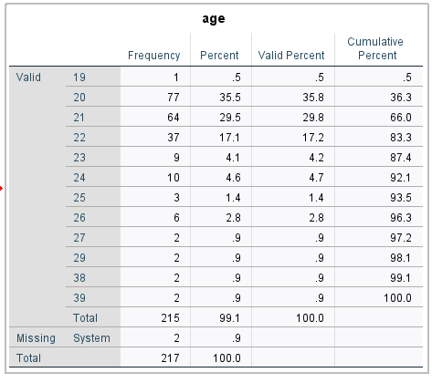

From the SPSS output, Under 21 years =19yrs and 20 years
$$=0.5+35.5=36\%$$

- Respondents reported when they drink alcoholic beverages in question #4 of the drinking survey. Which time option did students choose the most? Show a statistical output table and a histogram chart. (10 pts)
Solution
SPSS Output is as below:
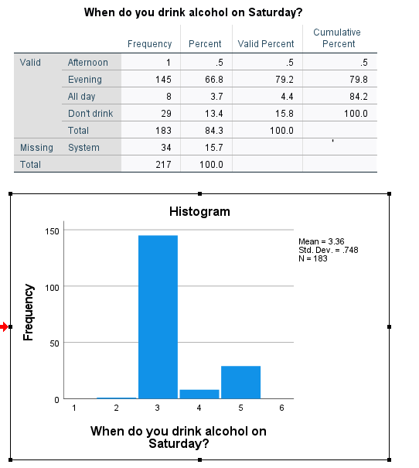
-The option that students chose the most is EVENING
-With a frequency of 145

- Respondents reported their preference for the alcoholic beverages in question #5 of the drinking survey. On average what type of alcoholic beverage is the most preferred? What is least preferred? (15 pts)
Solution
the SPSS output for the descriptive statistics is as below:
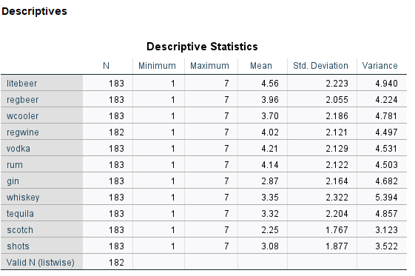
-From the table above, the type of alcoholic beverage that is most preferred is Litebeer; It has the largest mean (4.56)
-From the table above, the type of alcoholic beverage that is least preferred Scotch mixed drinks. It has the smallest mean (2.25).

- The respondents have different opinions regarding the statements in question #9 of the drinking survey. Which statement gets the most diverse opinions, and which one has the smallest variability? (15 pts)
Solution
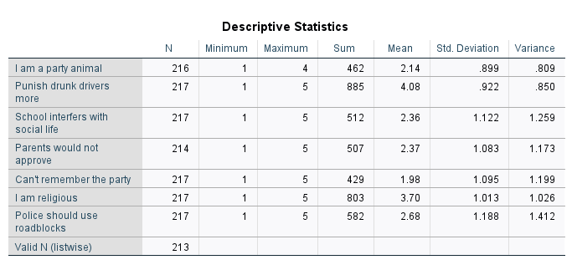
-From the SPSS output above, “Police should use road blocks”, has the most adverse opinions. It has the largest variance of 1.412.
-From the SPSS output above, “ I am a party animal” has the smallest variability: ( variance of 0.809)

- Compare the reason for drinking between juniors and seniors. Within juniors, what percent drink because “it relaxes me”? What about seniors? (10 pts)
Solution
SPSS output is as follows:
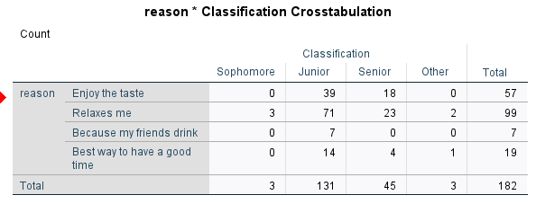
From the output,
Within juniors =$\frac{71}{182}*100\%≈39.01\%$
Within seniors =$\frac{23}{182}*100\%≈12.64\%$

- There may be a link between drinking and membership of a social fraternity or sorority. What percent of Greek Life members drink alcoholic beverages? What about non-members? (15 pts)
Solution
SPSS output is as shown below:
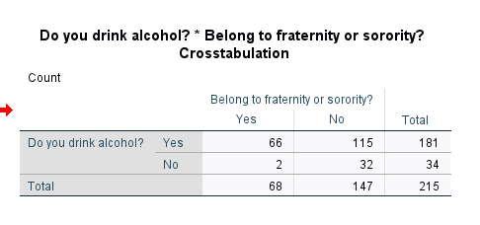
-Percent of Greek Life members drink alcoholic beverages=$\frac{115}{215}*100\%≈53.49\%$
-Percent of non-members=$\frac{66}{215}*100\%≈30.70\%$

- Females and males may differ in their self-reported drinker types. What percent of female drinkers are either moderate drinkers or heavy drinkers? What about male drinkers? (15 pts)
Solution
The SPSS output for crosstabulation is as below:
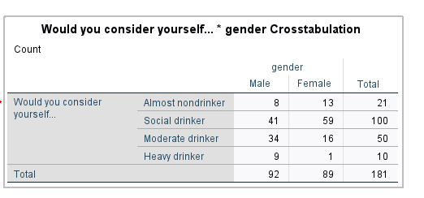
From the above table:
- percent of female drinkers are either moderate drinkers or heavy drinkers:
$$=\left(\frac{16+1}{181}\right)*100\%≈9.39\%$$
- percent of Male drinkers are either moderate drinkers or heavy drinkers:
$$=\left(\frac{34+9}{181}\right)*100\%≈23.76\%$$

